Add-on Course

Topic- Yoga: Guidance for Life

Academic session- 2021-22

Date: - 3rd March 2022 to 30th April 2022

Duration: - 30 Hours

List of students Registered and also completed the course

Sl,No | Name of students | Reg no. | Session | Signature of the students
01 | Md.Hasanur Rahaman | 068525 | 2019-20 | 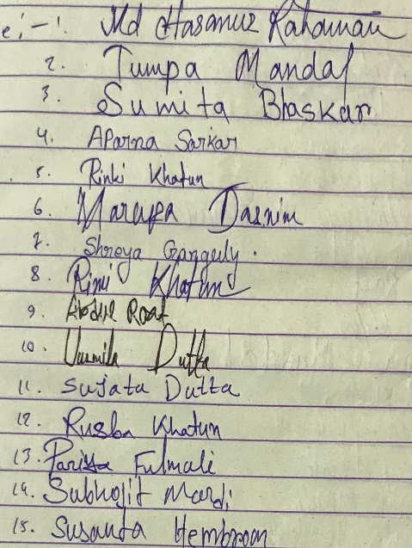
02 | Tumpa Mandal | 068302 | 2019-20
03 | Sumita Bhaskar | 068301 | 2019-20
04 | Aparna Sarkar | 066159 | 2017-18
05 | Rinki Katun | 071083 | 2018-19
06 | Marufa Tasnim | 071389 | 2018-19
07 | Shreya Ganguly | 068300 | 2019-20
08 | Rimi Khatun | 068406 | 2019-20
09 | Abdul Roaf | 070989 | 2018-19
10 | Urmila Dutta | 068206 | 2019-20
11 | Sujata Dutta | 070967 | 2018-19
12 | Rusba Khatun | 071090 | 2018-19
13 | Priya Fulmali | 071396 | 2018-19
14 | Subhojit Mardi | 071411 | 2018-19
15 | Susanta Hembrom | 080225 | 2018-19

